

**Group Project of**

DATA MINING (WQD 7005)

Milestone 2 - Management of data

**Title**

Store Data into HIVE Data Warehouse

**Instructor**

**Professor Dr. Teh Ying Wah**

**Group members**

|  |  |
| --- | --- |
| Sivanesan Pillai | WQD170074 |
| Mathavan Chandrasegaram | WQD170075 |

1. Created a directory into local system.

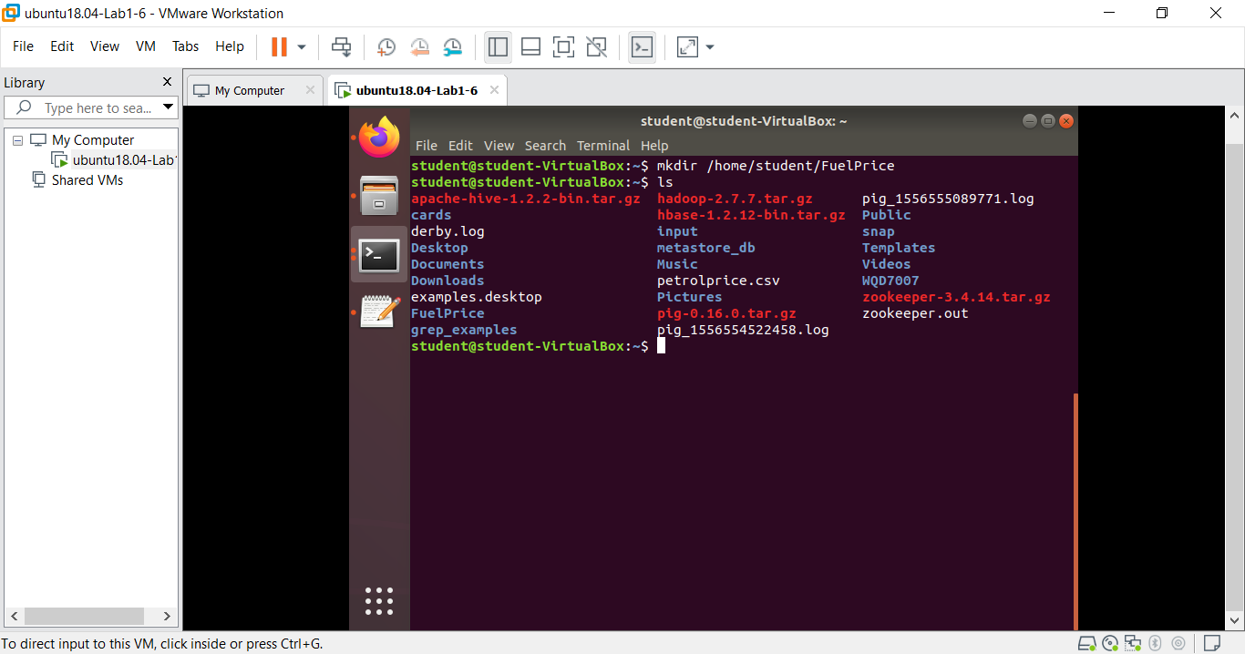

1. Save a data/file as in txt format into newly created directory.

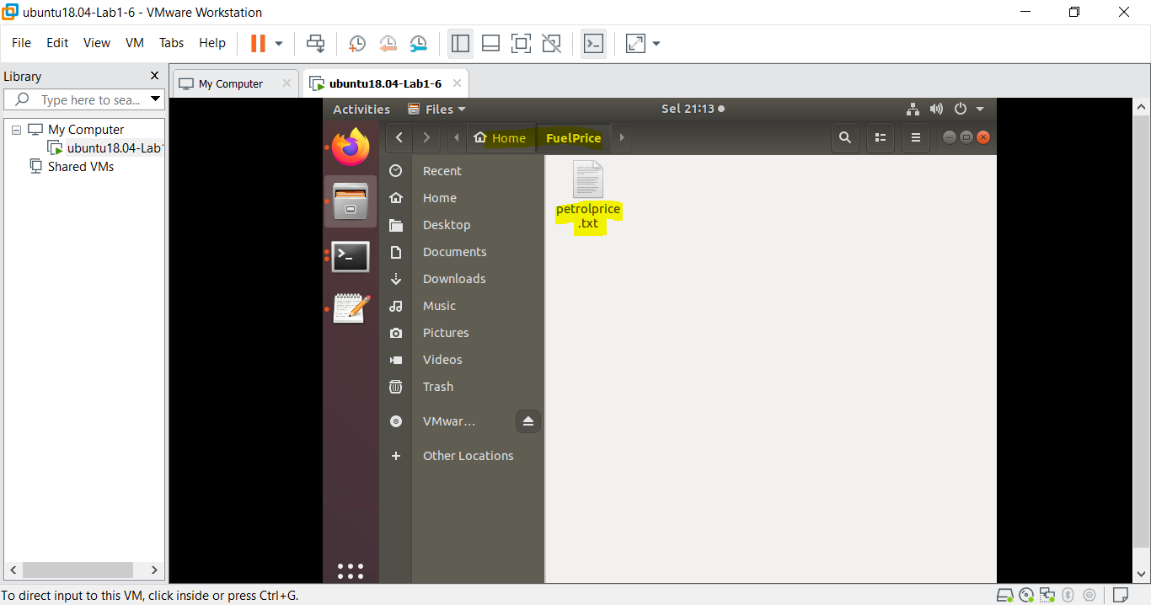

1. Locate and view the data file.

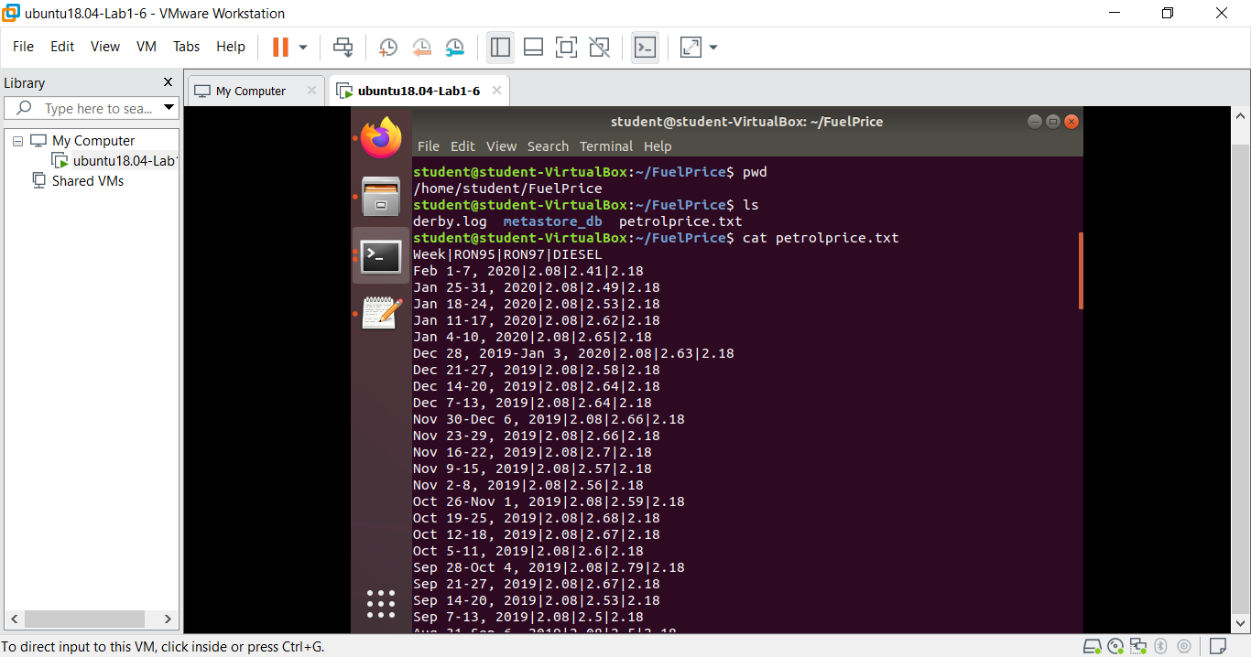

1. Launch “HIVE” – data warehouse

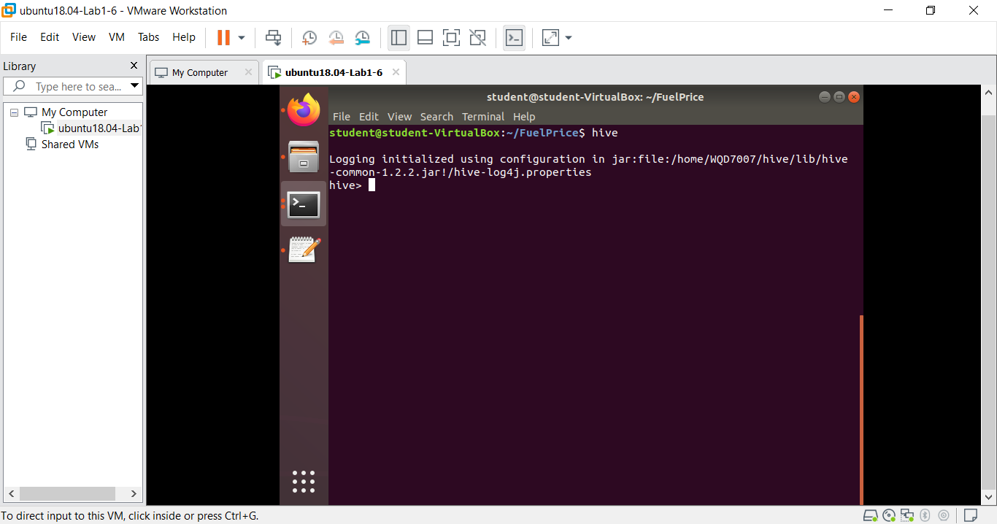

1. Check databases, create new database as petrol.

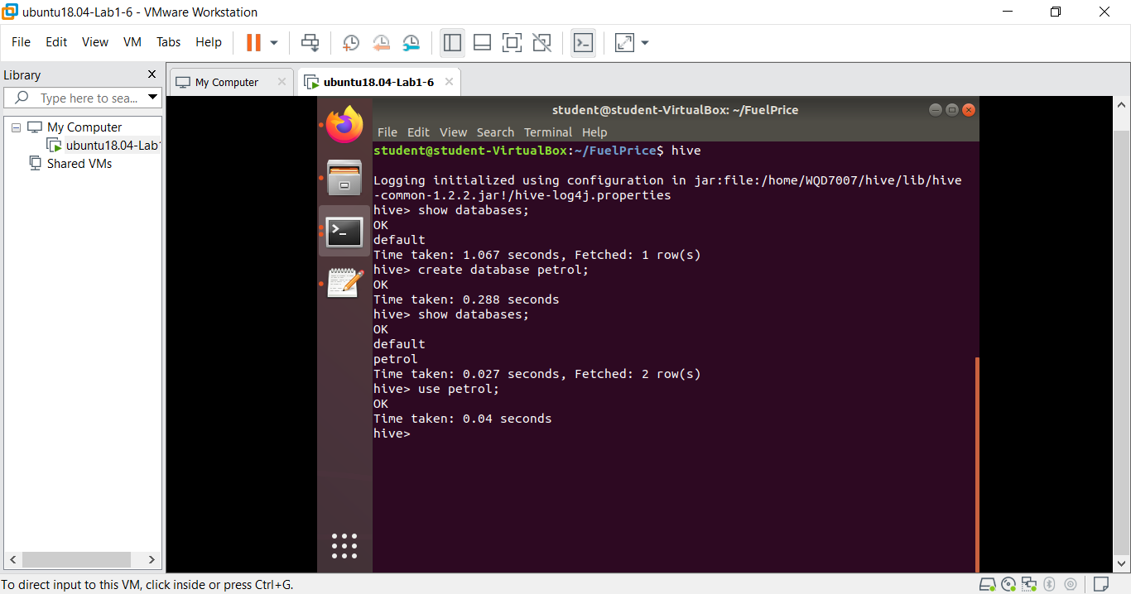

1. Use the newly created database (petrol), check for existing table, and create new table as petrol_price_new with defining all the required columns.

CREATE TABLE petrol_price_new (

week string,

RON95 double,

RON97 double,

DIESEL double)

ROW FORMAT DELIMITED FIELDS TERMINATED BY '|';

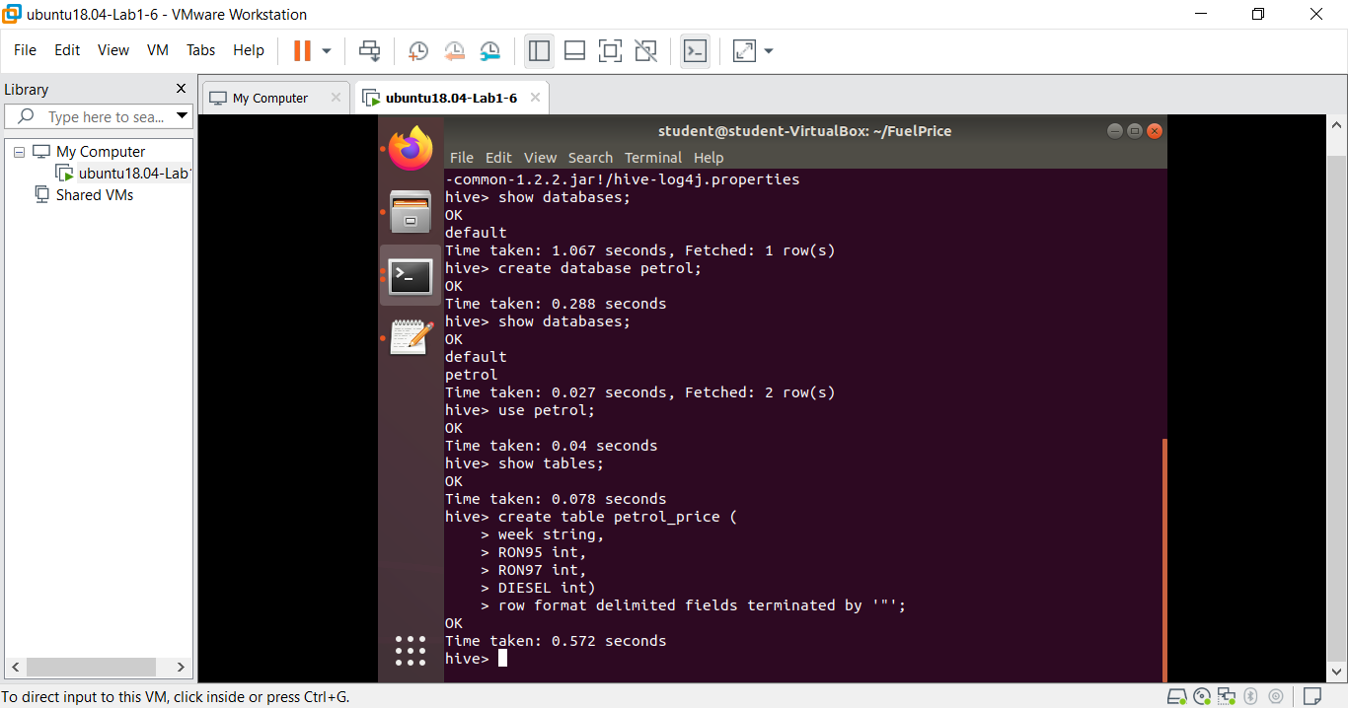

1. Load data from local file system into hive table.

LOAD DATA LOCAL INPATH '/home/student/FuelPrice/petrolprice.txt' INTO TABLE petrol_price_new;

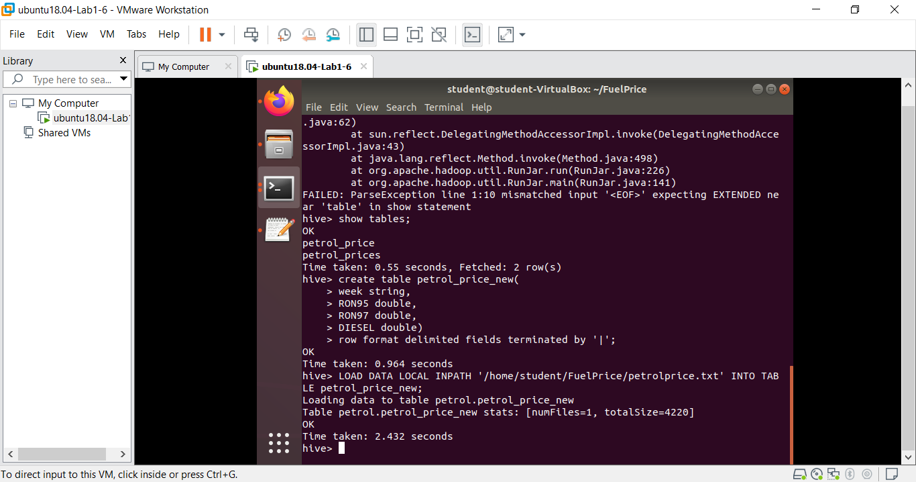

1. Check and verified the data (petrolprice.txt) has successfully loaded into HIVE table (data warehouse)

